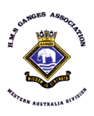

**Division Patron: Commander Philip Orchard AM AFNI RAN Ret.**

**WA DIVISION SUPPLEMENTARY HOIST APRIL 2023**

**Deepest sympathies are extended to the families and friends of George and Jim**

**Vale**

**George Edward Shand**

**Born 03/01/36 - CTB 02/03/23**

**Joined HMS Ganges 1951**

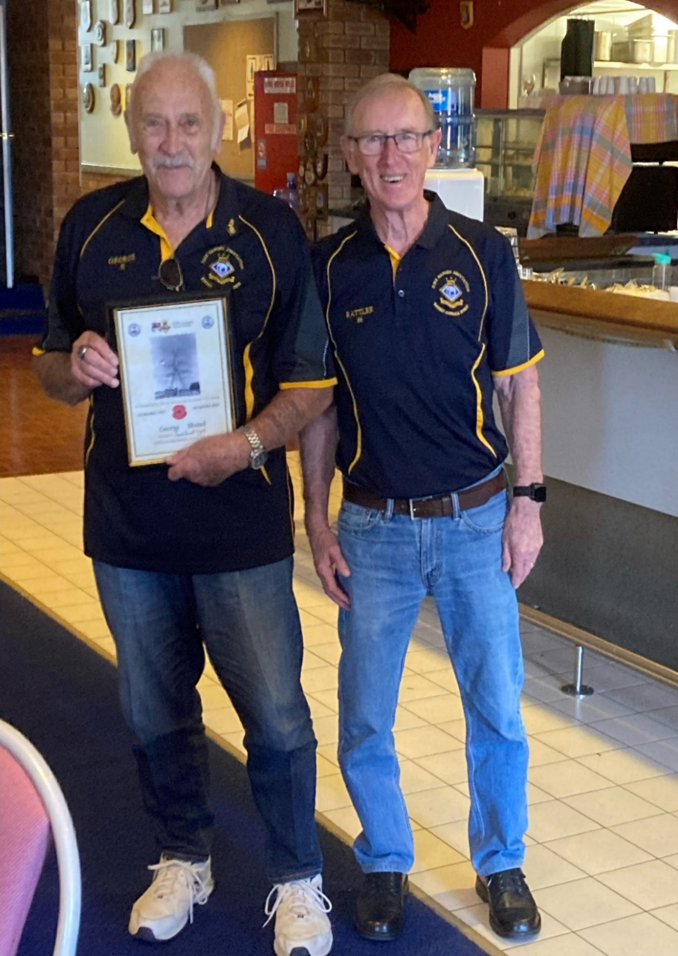

**George receiving his 70-year certificate.**

George was born in New York to Scottish parents who returned to Aberdeen, Scotlandduring his first year. Completing his training at HMS Ganges, George spent a couple of years with the surface fleet, then as an ABRP in 1956 he became a Submariner serving on TIRELESS, TOKEN & TALLY HO before paying off in 1961. George also met and married his jenny wren bride Sheila in Portsmouth in 1956. Sadly, Sheila passed away in 2008.

After paying off George joined London’s Metropolitan Police Service as a bobby on the beat, working his way up to a detective constable before leaving to emigrate to Western Australia in 1969. He joined the WA Police force for a couple of years then resigned to try hotel management with the Walkabout Hotels in Mount Newman and Geraldton. In the mid 1970’s George joined the WA Prison Service starting at Fremantle Prison and finishing at Canning Vale when he retired in 1996.

George maintained his navy links in WA, being a member of the WA Division of HMS Ganges Association and the Submariners Association. George also regularly attended the Mandurah RSL. He was a respected and well-liked member of the WA Division.

**Vale**

**James William Harry (Jim) Goad DSM BEM**

**Born 03/08/21 CTB 30/03/23**

**Joined HMS Ganges 1937**

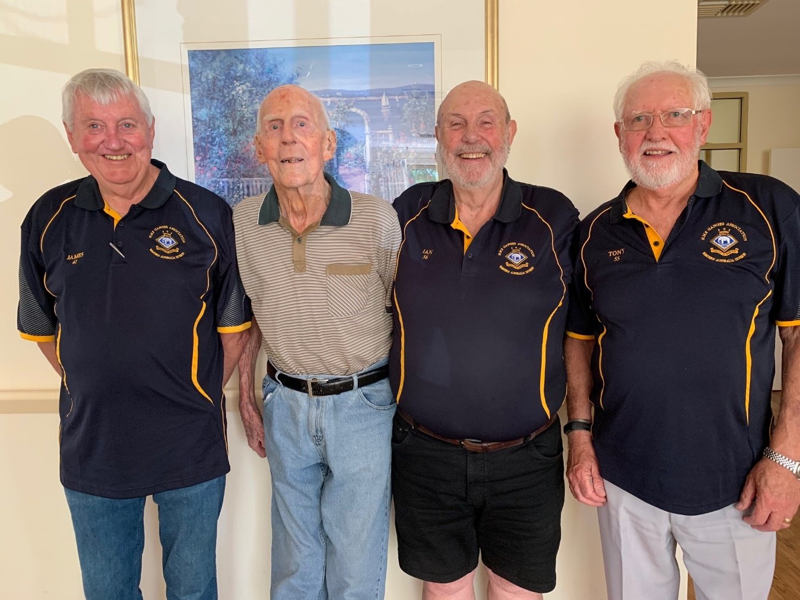

**Jim in 2021**

In 2021 an article placed in the West Australian newspaper, calling on ex-Ganges boys to make contact, was seen by Jim and contact was made with the WA Division. Jim was unaware the Ganges Association and the WA Division existed even though he had lived in WA since emigrating 1947. The story of Jim’s distinguished War and Civil Service was widely circulated within Ganges circles and was featured in the Spring 2021 edition of the Ganges Magazine. The following is a brief resume.

Jim left his home in Redhill, Surrey at 14 and joined TS Arethusa in January 1936 then joined the RNTE HMS Ganges in March 1937 as a gunnery rating. Jim was 19 and serving on HMS Kent when WWII began. In 1940 HMS Kent to passage to WA for escort duty of a military convoy taking ANZAC Troops to the Middle East, Jim met his future bride Dorothy whilst ashore in Fremantle. He was awarded the Distinguished Service Medal for bravery against enemy aircraft as an AB and Mentioned in Despatches as an A/PO whilst serving in HMS Lamerton during the war.

In September 1947 Jim emigrated to Western Australia marrying Dorothy in November 1947 in Trayning. In 1950 he joined the RAN Naval Dockyard Police and was initially based in HMAS Leeuwin; he was discharged from the RAN in 1970 but remained in the RAN Fleet Reserve until 1986. On discharge he remained ‘in service’ as a civilian with various duties at HMAS Leeuwin. Jim’s contribution to WA was recognised in 1982 when he was presented with the British Empire Medal (Civil Service).

Jim lived, with his wife Dorothy until she sadly passed away in 2010 aged 90, in the family home at Warwick, WA. After suffering several trips and falls during 2010/2020 resulted in multiple hip fractures, under sufferance 99-year-old Jim was required to enter residential aged care.

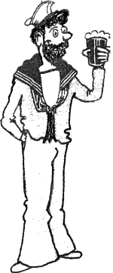

***Regards aye – Ian***

**Raise a glass to George and Jim**

**May they find calm seas and a safe anchorage**